**PROJECTAOS3**

1. The yaml file which I’m using for this project:

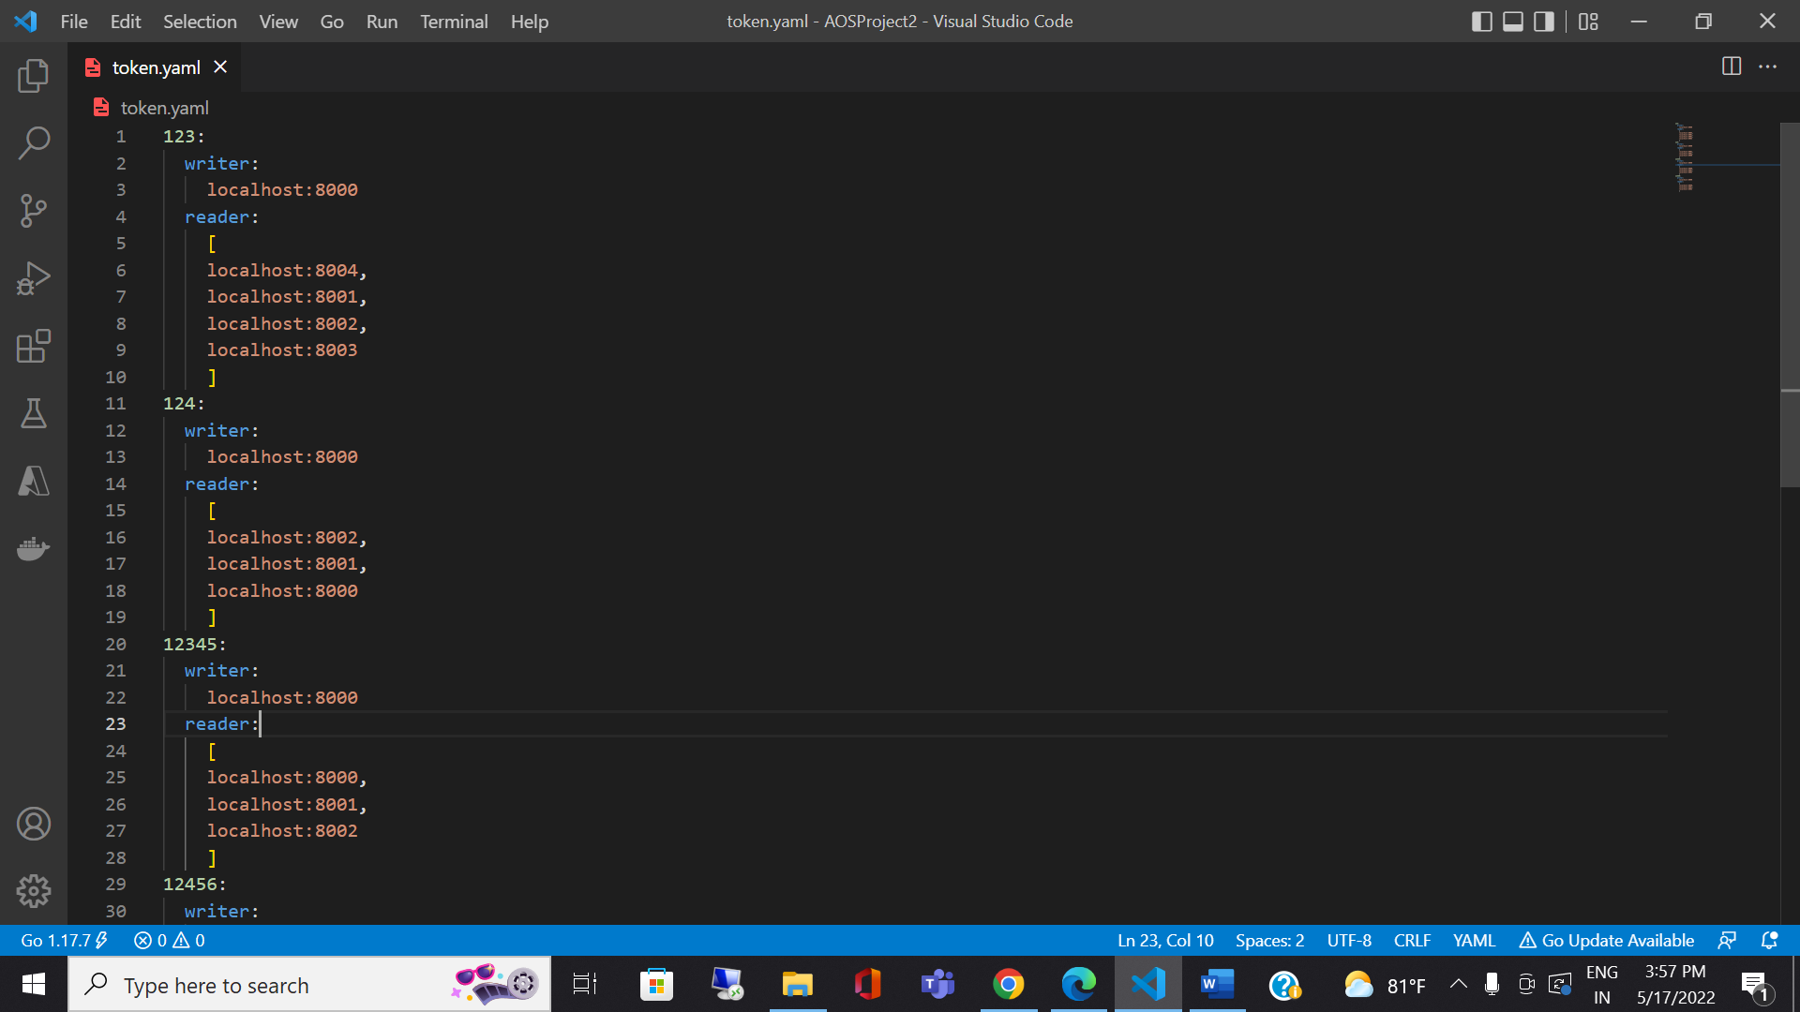

1. While starting the server itself I’m initializing the tokens:

1. Performing the write operation on one token and replicating it in other servers:

Client screen:

Writer node output:

Reader node output:

1. Now out of 3 nodes I’m shutting down one server and showing how replication is done

Server listening at 8001 port got stopped

Client output:

Writer node output:

Even though one server stopped the write performed successfully because its written more than half of the nodes

1. Now lets stop two nodes(more than n/2 servers got stopped):

Client screen:

writer screen: as its not committed in n/2+1 nodes this commit got discarded

6.performing the read operation and making it reflect in n/2+1 nodes to preserve read impose write all protocol:

Client output:

Server output:

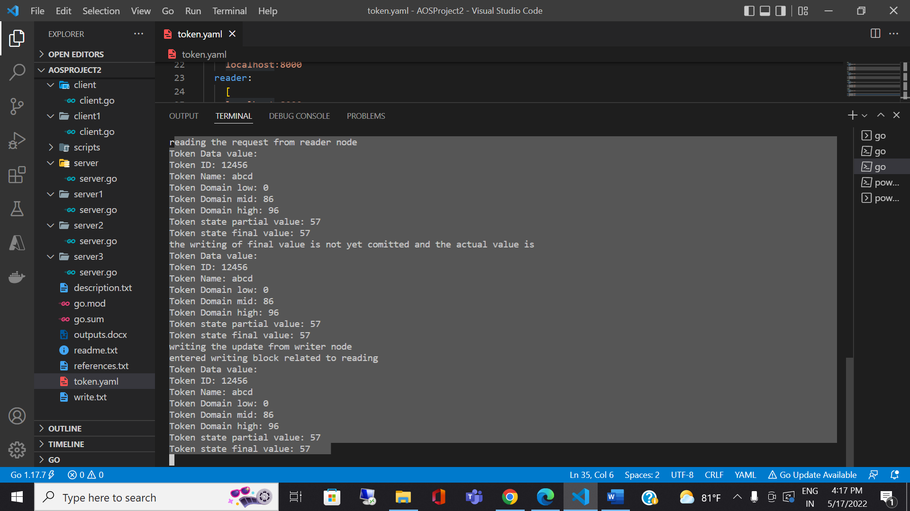

Making sure the commit is performed after reading back from all the nodes

Appending to the readlist and taking the highest counter value and using it to update all the reader nodes so that atomic semantics protocol is satisfied

1. While performing the read making sure that the last read value is reflected in n/2+1 nodes and if not displaying this message

Server output:

1. Fail silent behavior: I have performed this on the writer node 124

Client screen

Server screen:

For the other tokens still, the server is performing normally

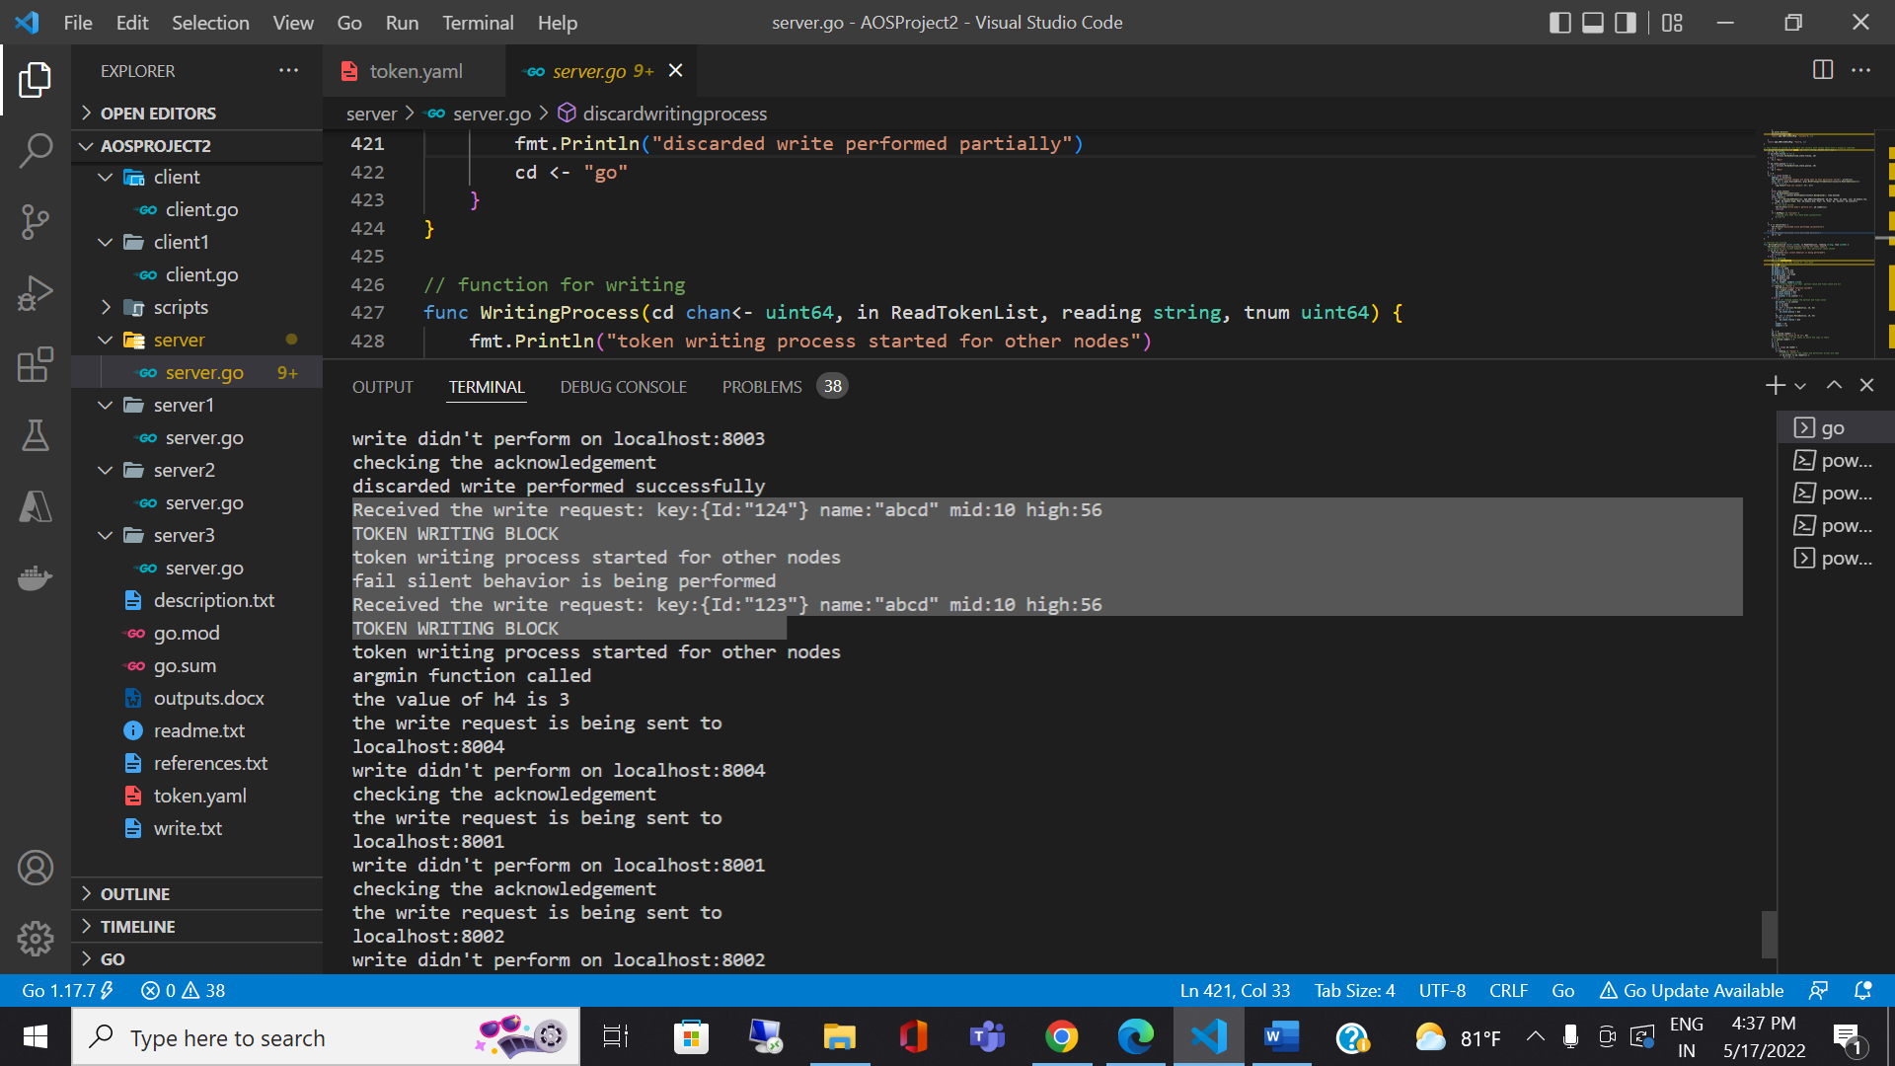

1. Performed creation and dropping from client side and made sure that this action is committed only when it is reflected in n/2+1 nodes.

Reader node output:

Writer node output:

